Gazipur Digital University
Department of Software Engineering
Course Titel : Object Oriented Programming
Course Code : PROG112

Submitted To: Md. Moshiur Rahman
Lecturer & Chairman Department of Software Engineering

Submitted By : Md. Akash Mia
ID:2303039
Session:2023-2024
Date of Submission:4/09/25

Lab Report 2

Experiment No.: 2

Title: Object Oriented Programming using Java (Class & Object Implementation)

Q1: Online Shopping System

Objective:
To design a simple Online Shopping System in Java where a customer can place an order for a product, and the system will display the order details such as Customer Name, Product Name, Quantity, and Total Price.

Theory:
- Class: Blueprint for creating objects (Customer, Product, Order).
- Object: Instance of a class.
- Constructor: Special method to initialize objects.
- Association: Relationship between classes (Order has Customer and Product objects).
Here,
- Product → Holds productId, name, price.
- Customer → Holds customerId, name, email.
- Order → Holds orderId, customer, product, quantity. It calculates total price and displays details.

Source Code:
public class Mavenproject3 {
// Product class
static class Product {
int productId;
String name;
double price;

Product(int productId, String name, double price) {
this.productId = productId;
this.name = name;
this.price = price;
}
}
// Customer class
static class Customer {
int customerId;
String name;
String email;

Customer(int customerId, String name, String email) {
this.customerId = customerId;
this.name = name;
this.email = email;
}
}
// Order class
static class Order {
int orderId;
Customer customer;
Product product;
int quantity;

Order(int orderId, Customer customer, Product product, int quantity) {
this.orderId = orderId;
this.customer = customer;
this.product = product;
this.quantity = quantity;
}

void displayOrderDetails() {
double totalPrice = product.price * quantity;
System.out.println("=== Order Details ===");
System.out.println("Customer Name: " + customer.name);
System.out.println("Product Name: " + product.name);
System.out.println("Quantity: " + quantity);
System.out.println("Total Price: $" + totalPrice);
}
}
// Main method
public static void main(String[] args) {
Customer customer = new Customer(1, "Rahim", "rahim@example.com");
Product product = new Product(101, "Laptop", 75000.0);
Order order = new Order(5001, customer, product, 2);

order.displayOrderDetails();
}
}

Output:
=== Order Details ===
Customer Name: Rahim
Product Name: Laptop
Quantity: 2
Total Price: $150000.0
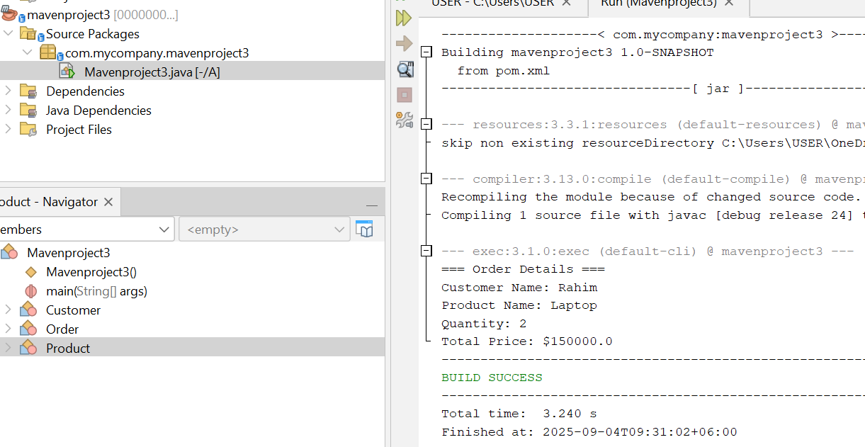

.

Q2: University Management System

Objective:
To design a simple University Management System in Java where a student can enroll in a course, and the system will display the enrollment details such as Student Name, Course Name, and Semester.

Theory:
- Student Class: Contains studentId, name, department.
- Course Class: Contains courseId, courseName, credits.
- Enrollment Class: Links student and course with semester information.
- Association: Enrollment class associates a Student with a Course.

Source Code:

package com.mycompany.mavenproject2;

public class Mavenproject2 {

// Student class

static class Student {

int studentId;

String name;

String department;

Student(int studentId, String name, String department) {

this.studentId = studentId;

this.name = name;

this.department = department;

}

}

// Course class

static class Course {

int courseId;

String courseName;

int credits;

Course(int courseId, String courseName, int credits) {

this.courseId = courseId;

this.courseName = courseName;

this.credits = credits;

}

}

// Enrollment class

static class Enrollment {

int enrollmentId;

Student student;

Course course;

String semester;

Enrollment(int enrollmentId, Student student, Course course, String semester) {

this.enrollmentId = enrollmentId;

this.student = student;

this.course = course;

this.semester = semester;

}

void displayEnrollmentDetails() {

System.out.println("=== Enrollment Details ===");

System.out.println("Student Name: " + student.name);

System.out.println("Course Name: " + course.courseName);

System.out.println("Semester: " + semester);

}

}

// Main method

public static void main(String[] args) {

Student student = new Student(1, "Karim", "Software Engineering");

Course course = new Course(101, "Object Oriented Programming", 3);

Enrollment enrollment = new Enrollment(1001, student, course, "Fall 2025");

enrollment.displayEnrollmentDetails();

}

}

Output:
=== Enrollment Details ===
Student Name: Karim
Course Name: Object Oriented Programming
Semester: Fall 2025

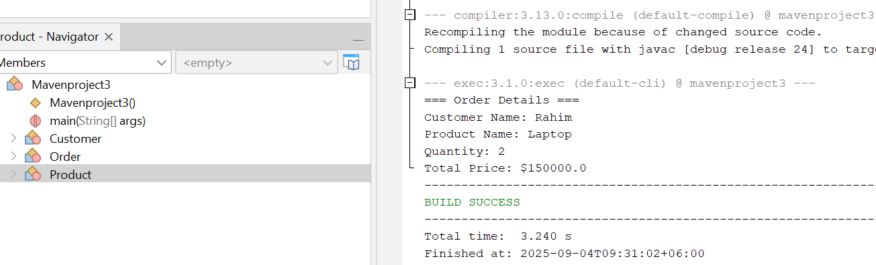

Conclusion:
This program demonstrates how objects of different classes can be associated to represent a real-world scenario. The Enrollment class connects Student and Course and shows the enrollment details.

